**INDEX**

**ABSTRACT i**

**LIST OF FIGURES ii-iii**

**LIST OF TABLES iv**

**CHAPTER 1: INTRODUCTION 1-6**

1.1Introduction1

1.2Existing System3

1.3Proposed System5

CHAPTER 2: PROBLEM DESCRIPTION7-8

**CHAPTER 3: BLOCKDIAGRAM, HARDWARE & SOFTWARE 9****-22**

3.1 Block diagram 9

3.2 Hardware Description 9-22

3.2.1 Battery 9

3.2.2 MEMS Sensor 10-12

3.2.3 Arduino nano 12-143.2.4 RF Transmitter 14

3.2.5 DC Motor15-16

3.2.6 L293D Motor Driver17-18

3.2.7 RF Receiver19

3.2.8 Mecanum Wheel 20-21

3.3 Software Description 22

**CHAPTER 4: DESIGN AND IMPLEMENTATION 23-27**

4.1 Design process 23-25

4.1.1 Transmitter Section 24

4.1.2 Receiver Section 25

4.2 Implementation 26-27

**CHAPTER 5: RESULT ANALYSIS**

**CHAPTER 6: ADVANTAGES,LIMITATIONS,APPLICATIONS**

**CHAPTER 7: FUTURE SCOPE 32**

**CHAPTER 8:CONCLUSION 33**

**CHAPTER 9: BIBLIOGRAPHY 34**

* 1. Glossary **35**
  2. Appendix**36-41**

**ABSTRACT**

Wireless hand Gesture Controlled mecanum wheel robot is a robot which can be controlled by human hand gestures. The user just needs to wear a gesture device in which a sensor is included. The sensor will record the movement of hand in a specific direction which will result in the motion of the robot in the respective directions. The robot and the Gesture instrument are connected wirelessly through radio waves. User can interact with the robot in a more friendly way due to the wireless communication. We can control the robotic wheel using accelerometer sensors connected to a hand glove. The sensors are intended to replace the remote control that is generally used to run the car. It will allow user to control the forward, backward, leftward and rightward movements, while using the same accelerometer sensor to control the throttle of the car. Movement of car is controlled by the differential mechanism.

The mechanism involves the rotation of both forth & rear wheels of left or right side to move in the anticlockwise direction and the other pair to rotate in the clockwise direction which makes the robot to rotate about its own axis without any kind of forward or backward motion. The main advantage of this mechanism is the car with this mechanism can take sharp turn without any difficulty. The design and implementation of a gesture control robotic arm using flex sensor is proposed. The robotic wheel is used by human hand movements by using hand glove.

i

**LIST OF FIGURES**

1. Figure 1.1 Mecanum Wheel1
2. Figure 1.2 Mecanum Wheel Robot2
3. Figure 1.3Mecanum Wheel Robot using Glove 2
4. Figure 1.4Sterring Vehicles 4
5. Figure 1.5Wheeled Mobile Robot 4
6. Figure 1.6Hand gestured controlled Mecanum Wheel Robot 5
7. Figure 1.7 Hand gestured controlled Mecanum Wheel Robot 6
8. Figure 3.1 HW Battery 9
9. Figure 3.2Alkaline Battery 10
10. Figure 3.3MEMS Sensor 11
11. Figure 3.4Pin diagram of MEMS Sensor 11
12. Figure.3.5Pin diagram of Arduino NANO 13
13. Figure.3.6RF Transmitter 14
14. Figure 3.7RF Transmitter circuit 15
15. Figure.3.8DC Motors 16
16. Figure.3.9L293D Motor Driver 17
17. Figure 3.10Pin diagram of L293D Motor Driver 17
18. Figure 3.11RF Receiver circuit 19
19. Figure.3.12Pin Layout of RF Module 20
20. Figure.3.13Mecanum Wheel Robot 20
21. Figure.3.14Mecanum Wheel 21
22. Figure 3.15Working direction of Mecanum Wheel 22
23. Figure 4.1 RF Transmitter 24
24. Figure 4.2Receiver Section 25
25. Figure 4.3 Hand gesture for Mecanum Wheel 26

ii

1. Figure 4.4 Hand Glove 27
2. Figure 4.5Omni Directional Wheel 27
3. Figure 6.1 Result analysis of the Mecanum Wheel 30

**LIST OF TABLES**

Table 1. Specification of MEMS Sensor 12

Table 2. Pin description of L293D Motor Driver 18

iv

## CHAPTER 1

## INTRODUCTION

### 1.1 INTRODUCTION

Background Today’s society is to a large scale dependent of microcontrollers. Things like cell phones, microwaves and refrigerators all have some kind of embedded system containing a microcontroller. One of the areas where microcontrollers are being used is within the factory industry, where microcontrollers are embedded in vehicles that transport goods. In order to fully utilize such vehicles, they need to be able to carry a heavy load while being flexible, which can be achieved using mecanum wheels . Mecanum wheels are included in the omnidirectional family of wheels and are therefore designed to be used for moving in any direction , which can be useful for many vehicles that require easier access and more direct movement, especially in narrow spaces.

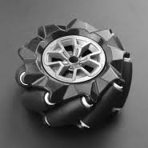

*Fig.1.1 Mecanum Wheel*

The options for remote control of today’s vehicles includes joysticks, but also gesture based control using cameras. Movement of an omnidirectional vehicle utilizing a camera have been shown working in a stable way when moving in a straight path . This approach however might not be suitable when steering a vehicle that requires a lot of moving, since it is difficult to have a camera constantly monitoring different gestures. An alternative approach to the camera that might be better suited to moving vehicles includes an IMU, where hand movements and directions are captured with the help of accelerometers and gyroscopes. This enables the user to move around the vehicle without being monitored by a camera. In order for the user to move freely, wireless data transfer is needed. One approach is to implement a Radio Frequency (RF) module, that enables data transfer wirelessly between the user and the vehicle .

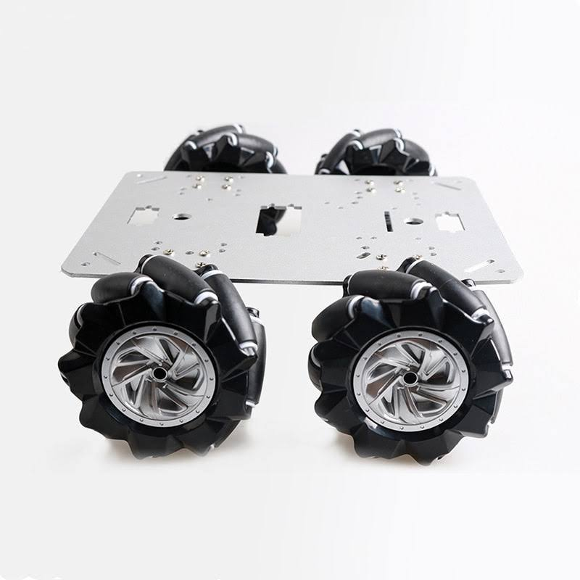

*Fig1.2: Mecanum wheel robot*

The purpose of this Bachelor’s Thesis is to design and construct a fully working prototype of a wireless hand gesture controlled omnidirectional vehicle. This thesis aims to investigate the following research questions:

• How can a omnidirectional vehicle be controlled using multiple hand gestures?

• How can hand gesture control be achieved wirelessly?

Since this is a Bachelor’s thesis with limited time and budget, multiple constraints were necessary. The main objective is to construct a working prototype of a omnidirectional vehicle that can be steered using hand gestures, therefore no time were spent designing the actual mecanum wheels. The majority of the necessary parts were purchased while some minor parts were 3D printed.

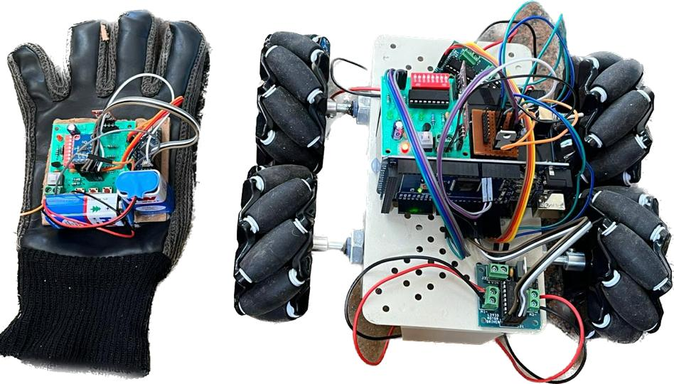

*Fig;1.3;Mecanum wheel robot using glove*

To answer the research questions related to this Bachelor’s thesis, different working methods were used. At an early stage, an extensive background study involving recent studies and theory about relevant components, such as omnidirectional wheels, wireless communication and hand gesture based steering was made. The information was mainly obtained from earlier thesis studies at Kungliga Tekniska H¨ogskolan (KTH), online sources and course literature. After the theoretical study this thesis was mainly about construction. The first step was to construct a moving vehicle without any form of hand gesture control. This was made by assembling the four Direct Current (DC) motors, together with four H-bridges. To control the motors an Arduino Uno was used. These components, necessary power supply and Mecanum wheels were all mounted to a bottom plate and making up the vehicle. The steering was implemented with an IMU by first connecting it to the onboard Arduino Uno. Later on the steering was made wireless using Radio Frequency (RF) communication. This was accomplished by connecting the onboard Arduino Uno with an RF reciever and an offboard Arduino Nano, to which the IMU and an RF transmitter were connected.using hand gesture sensor which is connected to hand glove that is accelerometer the mecanum wheel can be operated.

**1.2 EXISTING METHOD**

A steering wheel (also called a driving wheel (UK), a hand wheel, or simply wheel) is a type of steering control in vehicles.Steering wheels are used in most modern land vehicles, including all mass-production automobiles, buses, light and heavy trucks, as well as tractors. The steering wheel is the part of the steering system that is manipulated by the driver; the rest of the steering system responds to such driver inputs. This can be through direct mechanical contact as in recirculating ball or rack and pinion steering gears, without or with the assistance of hydraulic power steering, HPS, or as in some modern production cars with the assistance of computer-controlled motors, known as electric power steering.

Steering wheels for passenger automobiles are generally circular and are mounted to the steering column by a hub connected to the outer ring of the steering wheel by one or more spokes (single spoke wheels being a rather rare exception). Other types of vehicles may use the circular design, a butterfly shape, or some other shape. In countries where cars must drive on the left side of the road, the steering wheel is typically on the right side of the car (right-hand drive or RHD); the converse applies in countries where cars drive on the right side of the road (left-hand drive or LHD).

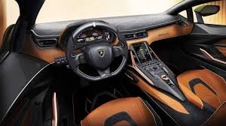

*Fig1.4: Steering vehicles*

In contrast, an adjustable steering column allows steering wheel height to be adjusted with only a small, useful change in tilt. Most of these systems work with compression locks or electric motors instead of ratchet mechanisms; the latter may be capable of moving to a memorized position when a given driver uses the car, or of moving up and forward for entry or exit.

Tilt wheel :The original tilt wheel was developed by Edward James Lobdell in the early 1900s. A 7-position tilt wheel was introduced by the Saginaw Division of General Motors in 1963 for all passenger car divisions except Chevrolet which received the tilt wheel in 1964. This tilt wheel was also supplied to the other US automakers (except Ford). Originally a luxury option on cars, the tilt function helps to adjust the steering wheel by moving the wheel through an arc in an up and down motion. Tilt Steering Wheels rely upon a ratchet joint located in the steering column just below the steering wheel. By disengaging the ratchet lock, the wheel can be adjusted upward or downward while the steering column remains stationary below the joint.

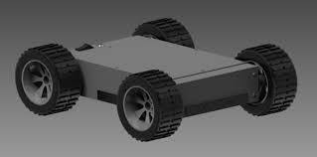

*Fig:1.5 Wheeled Mobile Robot*

## 

## 1.3 PROPOSED SYSTEM

In this project, we introduce a hand-gesture based control interface for navigating a car-robot. A 3-axis accelerometer is used to record a user’s hand gestures. The data is transmitted wirelessly via an RF module to a microcontroller. The received signals are then classified to one of six control commands for navigating a car-robot. The microcontroller then classifies the hand trajectories. Simulation results show that the classifier could achieve a 92.2% success rate.

Robots are playing an essential role in automation across all sectors like construction, military, medical, manufacturing, etc. After making some basic robots like a line follower robot, a computer-controlled robot, etc., we have developed this accelerometer-based gesture-controlled robot with an Arduino Uno. We have used hand gesture motion to drive the robot using an accelerometer.



*Fig1.6:Hand gesture controlled mecanum wheel robot*

A gesture-controlled robot is controlled by using the hand in place of any other method like buttons or joystick. Here one only needs to move the hand to operate the robot. A transmitting device is placed in the user’s hand, which contains the RF Transmitter and accelerometer to transmit a command to the robot so that it can perform the required task of moving forward, back, turning left, right and stop. These tasks will be identified using the hand gesture.Here the most crucial component is an accelerometer. An accelerometer is a 3-axis acceleration measurement device with +-3g range. This device is made by using a polysilicon surface sensor and signal conditioning circuit to measure acceleration. The output of this device is in Analog and also proportional to the acceleration. The device measures the static acceleration of gravity when tilted and gives a result in terms of ‘g’.

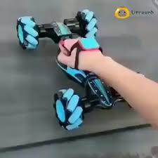

*Fig1.7:Hand gesture controlled mecanum wheel robot*

**CHAPTER 2**

# LITERATURE SURVEY

Diksha Goyal and Dr. S.P.S Saini Presented the “Accelerometer based hand gesture controlled wheelchair “Which describes the work in gesture reorganization use as application as a wheelchair. In this case was conducted is gesture is recognized through 3 axes accelerometer sensor. A system is consisting of use sensors for detecting the gesture or hand movements. In this system gesture is recognized by the MEMS accelerometer sensor (Micro Electro Mechanical System).An accelerometer is electromechanical device that measures the acceleration forces. This accelerometer sensor is 3 axes sensor it will attached at fingertips and back of hand .It is movable device. When it is move the gesture is recognized and wheelchair will operate according to the movement of sensor. After studying a design of “Accelerometer based hand gesture controlled wheelchair “one come to know the system is totally depend on sensor .If the sensor cannot move in angled position or direction this system cannot work hence this system is not as much as user friendly. This system does not provided the reliable support for disabled or handicapped person.

Feng-shengChen, Chin-Ming Fu, and Chung–LinHuang Presented the “Hand Gesture Recoganization using a real time tracking method and Hidden Markov Models” which describes the introduction on hand gesture reorganization system to recognize the continuous gesture before stationary background. In this system the motion of the object gives the important and useful information for object localization and extraction. Overall system includes four modules such as follows real time tracking, extraction, feature extraction, hidden Markov Model (HMM) training. To trace the moving hand and extract the hand region when applied the real time hand tracking and extraction algorithm. To characterize the spatial feature and motion analysis to characterize the temporal feature to use a Fourier Descriptor (FD).combine the spatial and temporal feature from input image sequences as our feature vector then apply the HMM model then recognize the input gesture. After studying a design of “Hand Gesture Reorganization using a real time tracking method and Hidden Markov Models” we observe that this system is depend on the HMM model to recognize to recognize the gesture. To recognizing the gesture the complexity is more and accuracy is less so it not beneficial and not compatible to the user.

Introduced more than 100 years ago, electric cars are seeing a rise in popularity today for many of the same reasons they were first popular. Whether it’s a hybrid, plug-in hybrid or all-electric, the demand for electric drive vehicles will continue to climb as prices drop and consumers look for ways to save money at the pump. Currently more than 3 percent of new vehicle sales, electric vehicles sales could to grow to nearly 7 percent -- or 6.6 million per year -- worldwide by 2020, according to a report by Navigant Research. With this growing interest in electric vehicles, we are taking a look at where this technology has been and where it’s going. Travel back in time with us as we explore the history of the electric car. The birth of the electric vehicle

It’s hard to pinpoint the invention of the electric car to one inventor or country. Instead it was a series of breakthroughs from the battery to the electric motor in the 1800s that led to the first electric vehicle on the road.In the early part of the century, innovators in Hungary, the Netherlands and the United States including a blacksmith from Vermont -- began toying with the concept of a battery-powered vehicle and created some of the first small-scale electric cars. And while Robert Anderson, a British inventor, developed the first crude electric carriage around this same time, it wasn’t until the second half of the 19th century that French and English inventors built some of the first practical electric cars.

Here in the U.S., the first successful electric car made its debut around 1890 thanks to William Morrison, a chemist who lived in Des Moines, Iowa. His six-passenger vehicle capable of a top speed of 14 miles per hour was little more than an electrified wagon, but it helped spark interest in electric vehicles.

Over the next few years, electric vehicles from different automakers began popping up across the U.S. New York City even had a fleet of more than 60 electric taxis. By 1900, electric cars were at their heyday, accounting for around a third of all vehicles on the road. During the next 10 years, they continued to show strong sales.

# CHAPTER 3

**BLOCK DIAGRAM, HARDWARE & SOFTWARE DESCRIPTION**

**3.1 BLOCK DIAGRAM**

* Reciever
* Transmitter

12v Battery

5v Battery

Arduino

Nano

Arduino

Nano

MOTOR1

MOTOR 3

MEMS

sensor

L293D

Motor

Driver

L293D

Motor

Driver

RF TX

MOTOR 4

MOTOR 2

### 3.2 HARDWARE DESCRIPTON

**3.2.1 BATTERY**

The battery can be used to power LEDs, Toys, Flashlight and Torch, electronic equipment like multimeter, wall clocks, or other devices with a 9V system. A battery snap connector is generally used to connect it with a breadboard

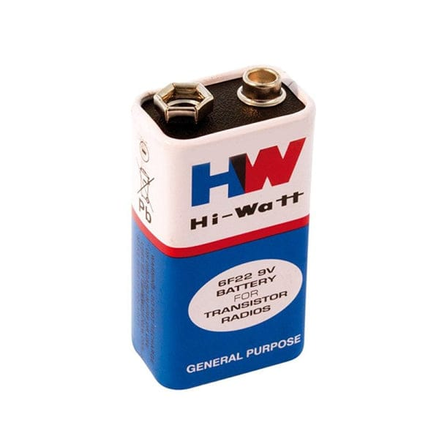

*Fig3.1:HW Battery*

In this project we use another battery which is called as Alkaline Battery. “An alkaline battery is a type of primary battery whose energy is derived from the reaction of zinc metal and manganese dioxide. It is also a disposable battery.” The alkaline battery gets its name from the fact that it uses an alkaline electrolyte of potassium hydroxide (KOH) rather than the acidic ammonium chloride (NH4Cl) or zinc chloride (ZnCl2) electrolyte used in zinc-carbon batteries. Other battery systems use alkaline electrolytes as well, but the active materials for the electrodes are different.Alkaline batteries have a higher energy density and a longer shelf life than zinc-carbon batteries of the Leclanché cell or zinc chloride types while providing the same voltage.An alkaline battery (IEC code: L) is a type of primary battery where the electrolyte (most commonly potassium hydroxide) has a pH value above 7. Typically these batteries derive energy from the reaction between zinc metal and manganese dioxide, nickel and cadmium, or nickel and hydrogen

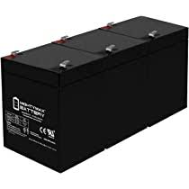

*Fig3.2:Alkaline Battery*

**3.2.2 MEMS SENSOR**

MEMS inclinometers and accelerometers are low-cost, high-precision inertial sensors that serve a wide variety of industrial applications.MEMS is a chip-based technology, known as a Micro Electro-Mechanical System.. Sensors are composed of a suspended mass between a pair of capacitive plates. When tilt is applied to the sensor, the suspended mass creates a difference in electric potential. The difference is measured as a change in capacitance.

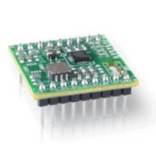

*Fig3.3:MEMS Sensor*

The greatest resolution you can get with a MEMS inclinometer is 0.0001° (JDI series). That’s a different story from the highly accurate electrolytic line. This line’s most sensitive tiltmeter (A603 tiltmeter) boasts a 2.5 nanoradian resolution. However, MEMS has some advantages of its own.

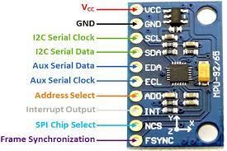

*Fig3.4:Pin Diagram of Mems Sensor*

A MEMS sensor provides the convenient features available with any other sensor line, but you don’t need to concern yourself with space constraints. MEMS utilizes very compact micro machine components so small that each sensor can fit into the palm of your hand. They have an IP67 seal and since the operating temperature range is -40° to +85°C, they will withstand some intense conditions. While electrolytic sensors have much higher accuracy, some of them can be sensitive to temperature.

These sensors are great solutions to applications that do not demand the highest accuracy such as industrial automation, platform leveling, position control, and pitch and roll measurement. Since they are low cost, you can even save some dough on your next big project.

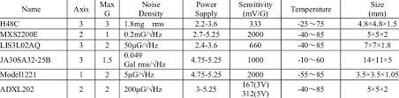

*Fig1:Specifications of MEMS Sensor*

**3.2.3 ARDUINO NANO**

The Arduino Nano is a compact board similar to the UNO. The Arduino Nano is a small, complete, and breadboard‐friendly board based onthe ATmega328 (Arduino Nano 3.x). It has more or less the same functionality ofthe Arduino Duemilanove, but in a different package. It lacks only a DC power jack,and works with a Mini‐B USB cable instead of a standard one. We can find in the Getting Started section all the information you need toconfigure your board, use the Arduino Software (IDE), and start tinker with codingand electronics.

This Arduino Nano is Original Arduino Nano Board. It is a breadboard-friendly board based on the ATmega328P from Arduino officials made in Italy. It has more or less the same functionality of the Arduino Duemilanove, but in a different package. It lacks only a DC power jack and works with a Mini-B USB cable instead of a standard one. Original Arduino Nano is a surface mount breadboard embedded version with integrated USB. It is the smallest, complete, and breadboard-friendly. It has everything that Diecimila/Duemilanove has (electrically) with more analog input pins and onboard +5V AREFjumper. Physically, it is missing power jack. The Nano is automatically sensing and switch to the higher potential source of power, there is no need for the power select jumper.

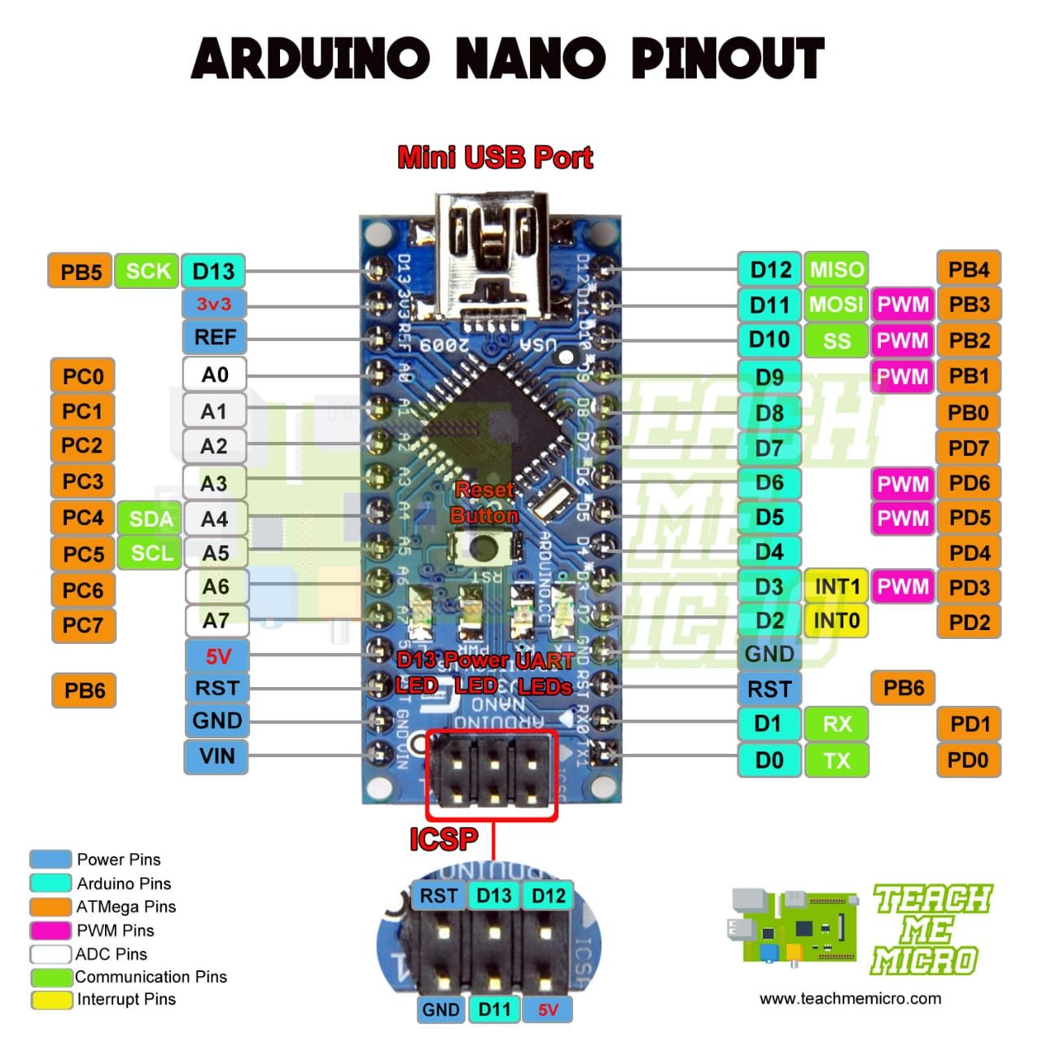

*Fig3.5:Pin diagram of Arduino Nano*

Nano’s got the breadboard-ability of the Board Arduino and the Mini+USB with a smaller footprint than either, so users have more breadboard space. It’s got a pin layouthigher potential source of power, there is no need for the power select jumper.This works well with the Mini or the Basic Stamp (TX, RX, ATN, GND on one top, power and ground on the other). This new version 3.0 comes with ATMEGA328 which offer more programming and data memory space. It is two layers. That makes it easier to hack and more affordable.

**SPECIFICATIONS:**

• Microcontroller: ATmega 328

• Architecture: AVR

• Operating voltage: 5V

• Flash memory: 32 KB of which 2 KB used by bootloader

• SRAM: 2 Kb

• Clock speed: 16 MHz

• Analog input pins: 8

• EEPROM: 1 Kb

• DC current per I/O pins: 40 ma (I/0 Pins)

• Input voltage: 7-12 V

**3.2.4 RF TRANSMITTER**

An RF module (short for radio-frequency module) is a (usually) small electronic device used to transmit and/or receive radio signals between two devices. In an embedded system it is often desirable to communicate with another device wirelessly. This wireless communication may be accomplished through optical communication or through radio-frequency (RF) communication. For many applications, the medium of choice is RF since it does not require line of sight. RF communications incorporate a transmitter and a receiver. They are of various types and ranges. Some can transmit up to 500 feet. RF modules are typically fabricated using RF CMOS technology.

RF modules are widely used in electronic design owing to the difficulty of designing radio circuitry. Good electronic radio design is notoriously complex because of the sensitivity of radio circuits and the accuracy of components and layouts required to achieve operation on a specific frequency. In addition, reliable RF communication circuit requires careful monitoring of the manufacturing process to ensure that the RF performance is not adversely affected. Finally, radio circuits are usually subject to limits on radiated emissions, and require Conformance testing and certification by a standardization organization such as ETSI or the U.S. Federal Communications Commission (FCC). For these reasons, design engineers will often design a circuit for an application which requires radio communication and then "drop in" a pre-made radio module rather than attempt a discrete design, saving time and money on development.

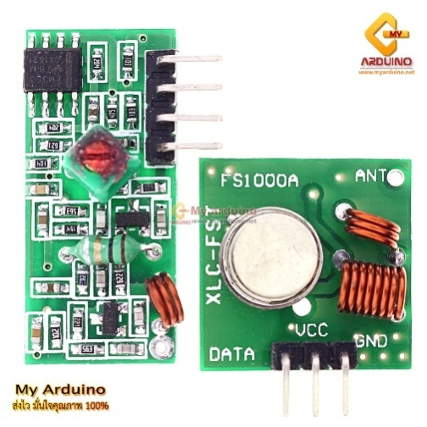

*Fig3.6:RF Transmitter*

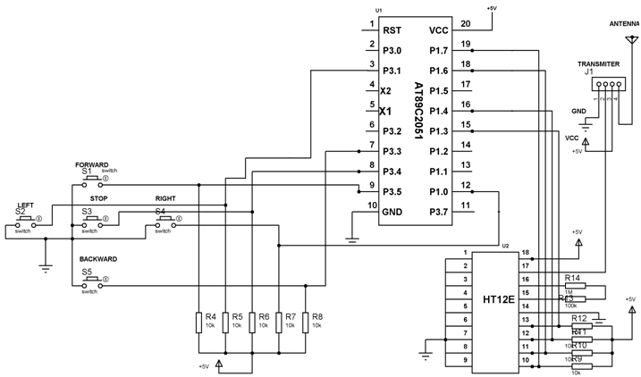

### *Fig 3.7: RF Transmitter Circuit*

RF modules are most often used in medium and low volume products for consumer applications such as garage door openers, wireless alarm or monitoring systems, industrial remote controls, smart sensor applications, and wireless home automation systems. They are sometimes used to replace older infrared communication designs as they have the advantage of not requiring line-of-sight operation.Several carrier frequencies are commonly used in commercially available RF modules, including those in the industrial, scientific and medical (ISM) radio bands such as 433.92 MHz, 915 MHz, and 2400 MHz.

**3.2.5 DC MOTOR**

A DC motor is an electromechanical energy conversion device, which converts electrical energy input into the mechanical energy output.The operation of the DC motor is based on the principle that when a current carrying conductor is placed in a magnetic field, a mechanical force acts on the conductor. The magnitude of the force is given by,F=BIlNewtonsThe direction of this is given by the Fleming’s left hand rule.

The magnetic field system of a DC motor is the stationary part of the machine. It produces the main magnetic flux in the motor. It consists of an even number of pole cores bolted to the yoke and field winding wound around the pole core. The field system of DC motor has salient poles i.e. the poles project inwards and each pole core has a pole shoe having a curved surface. The pole shoe serves two purposesIt provides support to the field coils.

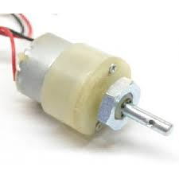

*Fig 3.8: DC Motors*

All the armature conductors under N pole carry current in one direction (say into the plane of the paper), whereas all the conductors under S pole carry current in the opposite direction (say out of the plane of the paper). As each conductor carrying a current and is placed in a magnetic field, hence a mechanical force acts on it.By applying Fleming’s left hand rule, it can be seen that the force on each conductor is tending to move the armature in anticlockwise direction. The force on all the conductors add together to exert a torque which make the armature rotating.

**SPECIFICATIONS**

* Frame sizes from 8 to 35 mm
* Speeds from 5,000 to 14,000 rpm
* Continuous motor torque - 0.36 to 160 mNm
* Coreless rotor design
* Low rotor inertia
* REE coil
* High power to weight ratio
* Neodymium magnet available in some brush DC motor models
* Sleeve and ball bearing versions
* High motion efficiency, that allows you to build a more compact, precise and energy-efficient solution

**3.2.6 L293D MOTOR DRIVER**

Even the simplest robot requires a motor to rotate a wheel or performs particular action. Since motors require more current than the microcontroller pin can typically generate, you need some type of a switch that can accept a small current, amplify it and generate a larger current, which further drives a motor. This entire process is done by what is known as a Motor driver. With L293D Motor Driver IC, that task is made simple and has helped in a number of applications with relative ease.

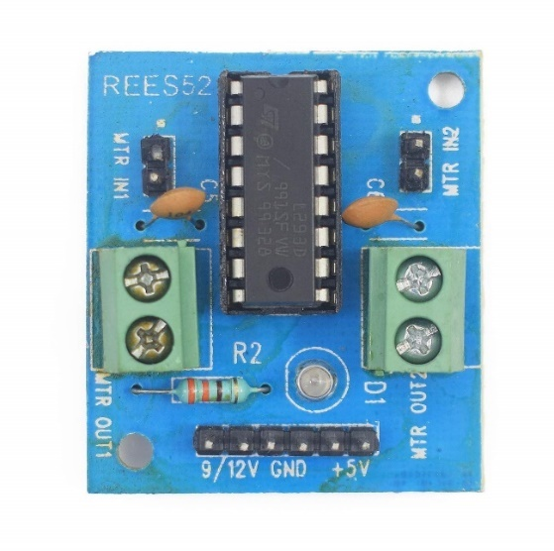

*Fig3.9: L293D Motor Driver*

L293D H-bridge driver is the most commonly used driver for Bidirectional motor driving applications. This L293D IC allows DC motor to drive on either direction. L293D is a 16-pin IC which can control a set of two DC motors simultaneously in any direction. It means that you can control two DC motor with a single L293D IC. Because it has two H-Bridge Circuit inside. The L293D can drive small and quiet big motors as well. There are various ways of making an H-bridge motor control circuit such as using transistors, relays, and using L293D/L298. Before going into detail, first we will see what is H-Bridge circuit.

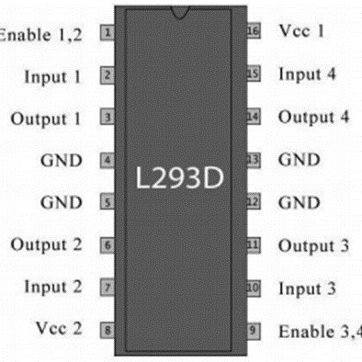

*Fig3.10:Pin diagram of L293D motor driver*

|  |  |  |
| --- | --- | --- |
| **Pin No.** | **Name** | **Function** |
| 1 | Enable 1-2 | When this pin is given HIGH or Logic 1, the left side of the IC works and when it is low, the left side doesn’t work. |
| 2 | INPUT 1 | When this pin is given HIGH or logic 1, the output 1 becomes HIGH. |
| 3 | OUTPUT 1 | This pin is connected to one of the terminals of the motor 1. |
| 4,5 | GND | Should be connected to the circuit’s ground. |
| 6 | OUTPUT 2 | This pin is connected to one of the terminals of the motor 1. |
| 7 | INPUT 2 | When this pin is given HIGH or Logic 1, the output 2 becomes HIGH. |
| 8 | VCC2 | This is the voltage required to run the motor. IT can be greater than the IC voltage(VCC1). |
| 16 | VCC1 | It provides power to the l293D IC. So, this pin should be supplied with 5 V. |
| 15 | INPUT 4 | When this pin is given HIGH or logic 1, the output 4 becomes HIGH. |
| 14 | OUTPUT 4 | This pin is connected to one of the terminals of the motor 2. |
| 13,12 | GND | Should be connected to the circuit’s ground. |
| 11 | OUTPUT 3 | This pin is connected to one of the terminals of the motor 2. |
| 10 | INPUT 3 | When this pin is given HIGH or logic 1, the output 3 becomes HIGH. |
| 9 | Enable 3-4 | When this pin is given HIGH or Logic 1, the right side of the IC works and when it is low, the right side doesn’t work. |

*Table2:Pin description of L293D Motor Driver*

**3.2.7 RF RECEIVER**

In general, the wireless systems designer has two overriding constraints: it must operate over a certain distance and transfer a certain amount of information within a data rate. The RF modules are very small in dimension and have a wide operating voltage range i.e. 3V to 12V.

Basically the RF modules are 433 MHz RF transmitter and receiver modules. The transmitter draws no power when transmitting logic zero while fully suppressing the carrier frequency thus consume significantly low power in battery operation. When logic one is sent carrier is fully on to about 4.5mA with a 3volts power supply. The data is sent serially from the transmitter which is received by the tuned receiver. Transmitter and the receiver are duly interfaced to two microcontrollers for data transfer.

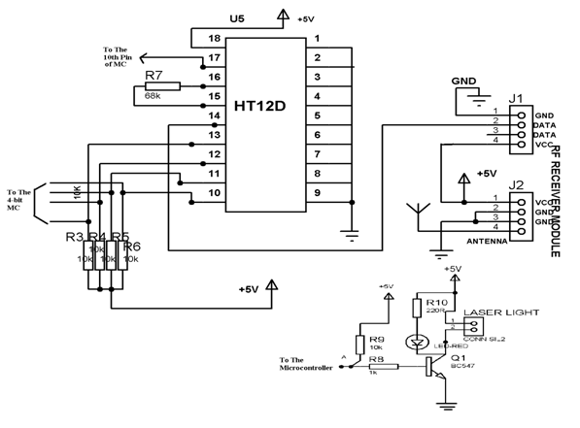

### *Fig3.11: RF Receiver Circuit:*

### FEATURES OF RF MODULE

* Receiver frequency 433MHz
* Receiver typical frequency 105Dbm
* Receiver supply current 3.5mA
* Low power consumption
* Receiver operating voltage 5v
* Transmitter frequency range 433.92MHz
* Transmitter supply voltage 3v~6v
* Transmitter output power 4v~12v

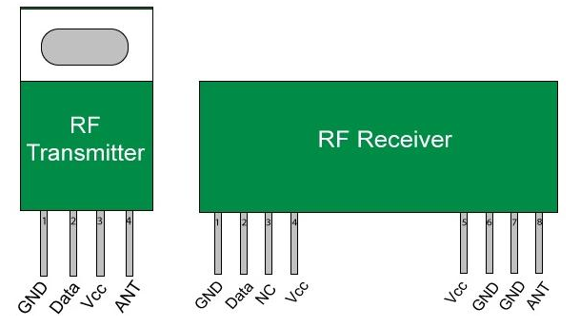

*Fig3.12: Pin layout of RF Module*

**3.2.8 MECANUM WHEELS**

The mecanum wheel is an omnidirectional wheel design for a land-based vehicle to move in any direction.The mecanum wheel is a form of tireless wheel, with a series of rubberized external rollers obliquely attached to the whole circumference of its rim. These rollers typically each have an axis of rotation at 45° to the wheel plane and at 45° to the axle line. Each Mecanum wheel is an independent non-steering drive wheel with its own powertrain, and when spinning generates a propelling force perpendicular to the roller axle, which can be vectored into a longitudinal and a transverse component in relation to the vehicle.

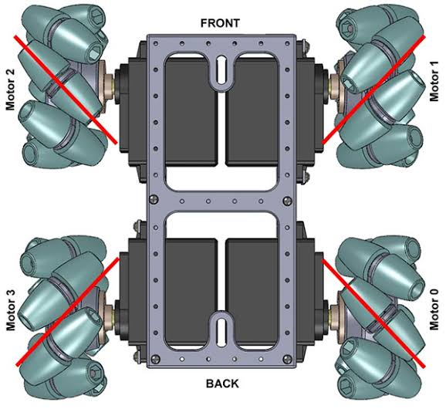

*Fig3.13: Mecanum Wheel Robot*

A Mecanum wheel is a wheel with rollers attached to its circumference. These rollers are positioned diagonally or at 45-degree angle to the axis of rotation of the wheel. This makes the wheel exert force in diagonal direction when moving forward of backward.

All four wheels move forward, the resulting move of the robot will be forward, and vice versa if all wheels move backward the robot will move backward. For moving to the right, the right wheels need rotate inside the robot, while the left wheels need rotate outside the robot. The resulting force due to the diagonally positioned rollers will make the robot move to the right. The same but opposite happens when moving to the left. With these wheels we can also achieve movement in diagonal direction by rotating only two wheels

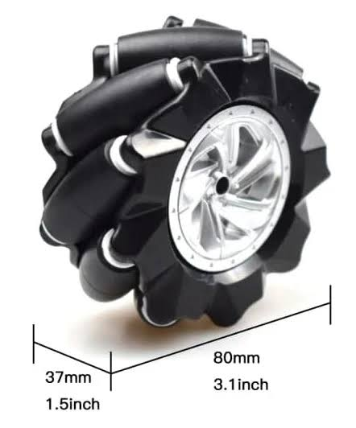

*Fig3.14:Mecanum Wheel*

Running all four wheels in the same direction at the same speed will result in a forward/backward movement, as the longitudinal force vectors add up but the transverse vectors cancel each other out;

Running (all at the same speed) both wheels on one side in one direction while the other side in the opposite direction, will result in a stationary rotation of the vehicle, as the transverse vectors cancel out but the longitudinal vectors couple to generate a torque around the central vertical axis of the vehicle;

Running (all at the same speed) the diagonal wheels in one direction while the other diagonal in the opposite direction will result in a sideways movement, as the transverse vectors add up but the longitudinal vectors cancel out.

A mix of differential wheel motions will allow for vehicle motion in almost any direction with any rotation.

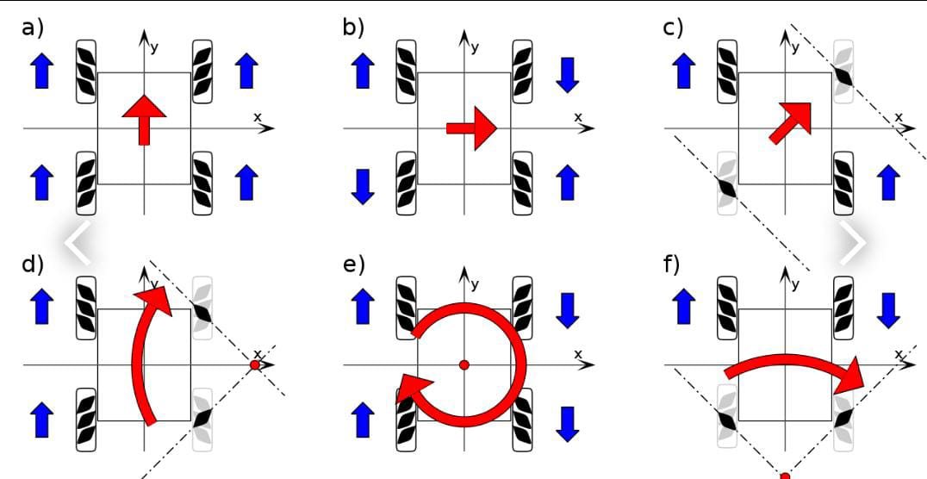

*Fig3.15:Working Direction of Mecanum Wheel*

**SPECIFICATIONS**

Diameter: 48mm/1.89”

Thickness: 24.5mm/0.96”

Hex Hole: 7*7*7mm

Number of Rollers: 9

Angle: 45°

Color: yellow

Material: plastic + silicone rubber

### 3.3 SOFTWARE DESCRIPTION

* Operating system - Windows 10/11
* Programming language - C++

**CHAPTER 4**

**DESIGN AND IMPLEMENTATION**

An Arduino Uno is used on the vehicle in order to handle the connections to the other necessary components. Since the vehicle is ment to operate remotely, the power supply to the microcontroller consisted of a 9V-battery, which is connected to the barrel jack on the Arduino Uno. Of the 14 avaiable digital pins, 13 are used for connections to the RF module and the motors. To control the four mecanum wheels, a DC motor for every wheel is needed. By connecting the motors to the onboard Arduino Nano together with an H-bridge (in the schematics, the H-bridges are dual, but the principle is the same) for every motor, it is possible to control the motors independent of one another. In order to vary the speed of the motors, all of the H-bridges need to be connected with two digital pins on the Arduino, where one of them supports PWM.

### 4.1 DESIGN PROCESS

A Robot is an electro-mechanical system that is operated by a computer program. Robots can be autonomous or semi-autonomous. An autonomous robot is not controlled by human and acts on its own decision by sensing its environment. Majority of the industrial robots are autonomous as they are required to operate at high speed and with great accuracy. But some applications require semi-autonomous or human controlled robots. Some of the most commonly used control systems are voice recognition, tactile or touch controlled and motion controlled. One of the frequently implemented motion controlled robot is a Hand Gesture Controlled Robot. In this project, a hand gesture controlled robot is developed using MPU6050, which is a 3-axis Accelerometer and 3-axis Gyroscope sensor and the controller part is Arduino Nano.

Instead of using a remote control with buttons or a joystick, the gestures of the hand are used to control the motion of the robot. The project is based on wireless communication, where the data from the hand gestures is transmitted to the robot over RF link (RF Transmitter – Receiver pair). The project is divided into transmitter and receiver section. The circuit diagram and components are explained separately for both transmitter and receiver sections. In order to understand the principle of operation of Hand Gesture Controlled Robot, let us divide the project into three parts.

The first part is getting data from the MPU6050 Accelerometer Gyro Sensor by the Arduino. The Arduino continuously acquires data from the MPU6050 and based on the predefined parameters, it sends a data to the RF Transmitter.The second part of the project is the Wireless Communication between the RF Transmitter and RF Receiver. The RF Transmitter, upon receiving data from Arduino (through the Encoder IC), transmits it through the RF Communication to the RF Receiver.

**4.1.1 TRANSMITTER SECTION**

Tr section Arduino Nano board, MPU6050 Sensor, HT-12E Encoder IC and an RF Transmitter. The communication between Arduino and MPU6050 Sensor takes place through I2C Interface. Hence, the SCL and SDA pins of the MPU6050 Sensor are connected to A5 and A4 pins of the Arduino Nano. Additionally, we will be using the interrupt pin of the MPU6050 and hence, it is connected to D2 of Arduino Nano.

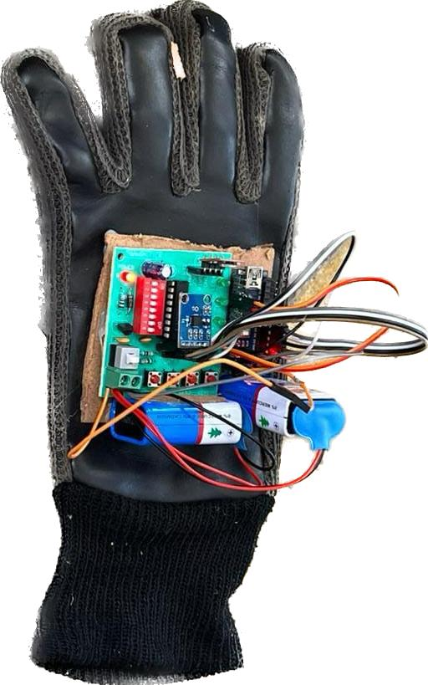

*Fig4.1: RF Transmitter*

Encoder IC that is often associated with RF Transmitter module. It converts the 12-bit parallel data to serial data. The 12-bit data is divided into address and data bits. A0 to A7 (Pin 1 to Pin8) are the address bits and they are used for secure transmission of the data. These pins can be either left open or connected to ground (Vss). In this circuit, Pin 1 to Pin 9 (A0 – A7 and Vss) of HT-12E are connected to ground.Pins 10 to 13 (AD8, AD9, AD10 and AD11) are the data pins of HT-12E. They receive the 4 word parallel data from external source like a microcontroller (Arduino Nano in this case). They are connected to the pins D12, D11, D10 and D9 of Arduino Nano respectively.TE’ is the transmission enable pin and it is an active low pin. The data is transmitted as long as the TE’ is low. Hence, Pin 14 (TE’) is also connected to ground.The encoder IC has an internal oscillator circuit between the pins 16 and 15 (OSC1 and OSC2). A 750KΩ resistor is connected between these pins to enable the oscillator. Dout (Pin 17) is the serial data out pin. It is connected to the data in pin of the RF Transmitter.Both Arduino Nano and MPU6050 have 3.3V Regulator. Hence, all the VCC pins are connected to a regulated 5V Supply

**4.1.2 RECIVER SECTION**

The RF Receiver receives the serial data and transmits it to the Decoder IC. The Decoder will convert the serial data to parallel data and this parallel data is given to the motor driver IC. Based on the data, the movement of the motors, and hence the movement of the robot is defined . Working of Hand Gesture Controlled Robot

In this project, a mobile robot that is controlled by the gestures made by the hand, is designed. The working of the robot is explained here. As mentioned earlier, the gesture controlled robot is a wireless operated robot and has two parts: Transmitter and Receiver. When the robot is powered on, the transmitter part, which consists of Arduino, MPU6050, Encoder and RF Transmitter, will continuously monitor the MPU6050 sensor. This data is captured by the Arduino, which then transmits a corresponding data to the Encoder, based on the orientation of the MPU6050 Sensor.

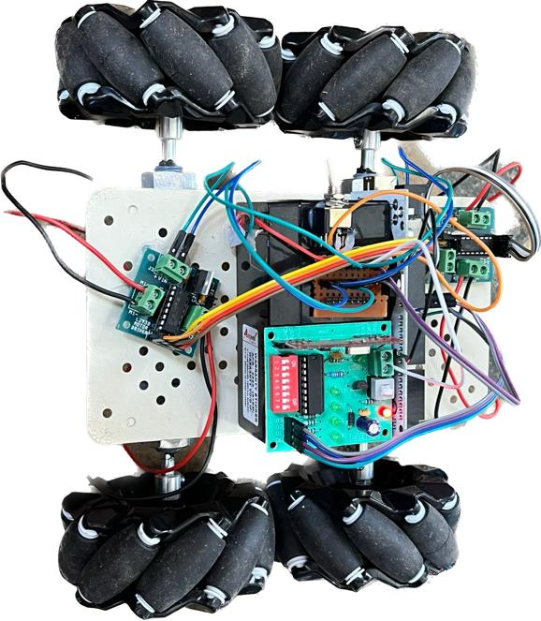

*Fig4.2: Receiver Section*

The parallel data received by the encoder is converted into serial data and this serial data is transmitted by the RF Transmitter. configuration, with two wheels on each side of the chassis. Using four of these wheels provides omni-directional movement for a vehicle without needing a conventional steering system. In our case, we have chosen a square configuration, in order to simplify the mathematical model and, obviously, the motion control of it Our robot is a 450 [mm] long, 382 [mm] wide and 220 [mm] high platform. Each wheel is actuated by its own DC geared MAXON motor. Because the omni-directional capability of the robot depends on each wheel resting firmly on the ground, some are equipped with suspension systems. Even if these designs are for indoor applications (this Omnidirectional Mobile Robot – Design and Implementation 521means they are moving on flat surfaces), having four wheels, they need a suspension system just in case of small waves that could exist on the ground. In our case, a passive suspension system with two spatial four-bar mechanisms ( ABCD and ' ' ' 'ABCD, serial connected) is used, in order to easy adapt the system to the ground.

### 4.2 IMPLENTATION

978-1-5386-9111-3/19/$31.00 ©2019 IEEE

IV.I

MPLEMENTATION

A prototype of the hand gestured controlled maneuvering

robot has been developed which will follow the direction as

per given by common known patterns. It follows five

different gestures made by hand to perform its directional

movement.

A.Tasks performed by the robot

Fig. 5 shows the gestures made by the physically

challenged or elderly people.

1.Stop/Steady -- when it gets hand gesture that is

parallel with horizontal

2.Front/Forward -- when it gets hand gesture that is

creating highest -90 degree (≅) in Y axis

3.Rear -- when it gets hand gesture that is creating

highest +90 degree (≅) in Y axis

4.Left -- when it gets a hand gesture that is creating

highest -90 degree (≅) in X axis

5.Right -- when it gets a hand gesture that is creating

highest +90 degree (≅) in X axis

A prototype of the hand gestured controlled manevering robot has been developed which will follow the direction as per given by common known patterns. It follows five different gestures made by hand to perform its directional movement.

1. Stop/Steady -- when it gets hand gesture that is parallel with horizontal

2. Front/Forward -- when it gets hand gesture that is creating highest -90 degree (≅) in Y axis

3. Rear -- when it gets hand gesture that is creating highest +90 degree (≅) in Y axis

4. Left -- when it gets a hand gesture that is creating highest -90 degree (≅) in X axis

5. Right -- when it gets a hand gesture that is creating highest +90 degree (≅) in X axis

978-1-5386-9111-3/19/$31.00 ©2019 IEEE

IV.I

MPLEMENTATION

A prototype of the hand gestured controlled maneuvering

robot has been developed which will follow the direction as

per given by common known patterns. It follows five

different gestures made by hand to perform its directional

movement.

A.Tasks performed by the robot

Fig. 5 shows the gestures made by the physically

challenged or elderly people.

1.Stop/Steady -- when it gets hand gesture that is

parallel with horizontal

2.Front/Forward -- when it gets hand gesture that is

creating highest -90 degree (≅) in Y axis

3.Rear -- when it gets hand gesture that is creating

highest +90 degree (≅) in Y axis

4.Left -- when it gets a hand gesture that is creating

highest -90 degree (≅) in X axis

5.Right -- when it gets a hand gesture that is creating

highest +90 degree (≅) in X axis

978-1-5386-9111-3/19/$31.00 ©2019 IEEE

IV.I

MPLEMENTATION

A prototype of the hand gestured controlled maneuvering

robot has been developed which will follow the direction as

per given by common known patterns. It follows five

different gestures made by hand to perform its directional

movement.

A.Tasks performed by the robot

Fig. 5 shows the gestures made by the physically

challenged or elderly people.

1.Stop/Steady -- when it gets hand gesture that is

parallel with horizontal

2.Front/Forward -- when it gets hand gesture that is

creating highest -90 degree (≅) in Y axis

3.Rear -- when it gets hand gesture that is creating

highest +90 degree (≅) in Y axis

4.Left -- when it gets a hand gesture that is creating

highest -90 degree (≅) in X axis

5.Right -- when it gets a hand gesture that is creating

highest +90 degree (≅) in X axis

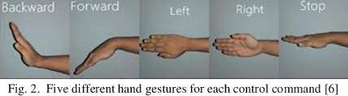

*Fig4.3 : Hand Gesture for Mecanum Wheel*



*Fig4.4 : Hand Glove*

1. Gyroscope’s sensor senses the hand gesture movement from hand to microcontroller.

2. MCU receives the data and make instructions for the robot.

3. Sends the instruction to the encoder IC.

4. Encoded data transmits through the transmitter.

5. In the receivers end the receiver receives the encoded data.

6. Receiver sends the encoded data to the decoder.

7. Decoder decodes the data and sends to the motor driver.

8. Motor driver drives the motor in all movements by following the instruction and gestures.

9. Finally, the robot moves with the gestures.

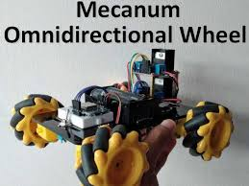

*Fig4.5: Omni directional Wheel*

**CHAPTER-5**

**RESULT ANALYSIS**

A neural network is a network or circuit of neurons, or in a modern sense, an artificial neural network, composed of artificial neurons or nodes. A neural network (NN), in the case of artificial neurons is an interconnected group of natural or artificial neurons that uses a mathematical model for information.ANN algorithm will be trained with all previous users fake and genuine account data and then whenever we gave new test data then that ANN train model will be applied on new test data to identify whether given new account details are from genuine or fake users.

**Step-1:Giving Input:**

Here we are giving the input profile name as ‘Shireesha’ that is the user will give any profile name which is going to be displayed on the webpage display in this result whether the profile is authentic or not.



***Figure.6.1*** *Giving input*

**Step-2: Internal Processing:**

The ANN algorithm compares the username with datasets present in the particular location of PC .



***Figure.6.2*** *comparing with the dataset*

**Step-3: Final output:**

If the username present in the dataset then that will be displayed as authentic profile or else the output will be displayed as fake profile.



***Figure.6.3*** *Displays output*

**CHAPTER-6**

**ADVANTAGES, LIMITATIONS AND APPLICATIONS**

**ADVANTAGES:**

There are various advantages of neural networks, some of which are discussed below:

* Store information on the entire network Just like it happens in traditional programming where information is stored on the network and not on a database. If a few pieces of information disappear from one place, it does not stop the whole network from functioning.
* **The ability to work with insufficient knowledge:**

After the training of ANN, the output produced by the data can be incomplete or insufficient. The importance of that missing information determines the lack of performance.

* **Good fault tolerance:**

The output generation is not affected by the corruption of one or more than one cell of artificial neural network. This makes the networks better at tolerating faults.

* **Distributed memory:**

For an artificial neural network to become able to learn, it is necessary to outline the examples and to teach it according to the output that is desired by showing those examples to the network. The progress of the network is directly proportional to the instances that are selected.

* **Gradual Corruption:**

Indeed a network experiences relative degradation and slows over time. But it does not immediately corrode the network.

* **Ability to train machine:**

ANN learn from events and make decisions through commenting on similar events.

* **The ability of parallel processing:**

These networks have numerical strength which makes them capable of performing more than one function at a time.

### LIMITATIONS

* Hardware dependence: Artificial neural networks require processors with parallel processing power, in accordance with their structure. For this reason, the realization of the equipment is dependent.
* Unexplained behavior of the network: This is the most important problem of ANN. When ANN produces a probing solution, it does not give a clue as to why and how. This reduces trust in the network.
* Determination of proper network structure: There is no specific rule for determining the structure of artificial neural networks. Appropriate network structure is achieved through experience and trial and error.
* Difficulty of showing the problem to the network: ANNs can work with numerical information. Problems have to be translated into numerical values before being introduced to ANN. The display mechanism to be determined here will directly influence the performance of the network. This depends on the user's ability.
* The duration of the network is unknown: The network is reduced to a certain value of the error on the sample means that the training has been completed. This value does not give us optimum results.

### APPLICATIONS

* Image result for applications of identifying fake profiles using ann
* Artificial neural networks are used for a range of applications, including image recognition, speech recognition, machine translation, and medical diagnosis. The fact that ANN learns from sample data sets is a significant advantage. The most typical application of ANN is for random function approximation.
* This algorithm is also used to detect fake profiles on other social media websites like facebook and Instagram etc..

**CHAPTER 7**

**FUTURE SCOPE**

For future work there are several key aspects that might be considered in order to improve the overall user experience and design. Since a vehicle utilizing the mecanum wheels have the possibility of moving not only forward and backwards, but also horizontally and diagonally, the mounting of the wheels and corresponding motors are important. Since it is the resulting forces on the wheels that decide in what direction the vehicle will move, it is crucial to mount the wheels as aligned with each other as possible, since the vehicle otherwise have a high likelihood of not moving in the desired direction. Furthermore, the choice of material on the rollers which are attached on the mecanum wheels will have a high impact on the performance. Since materials like plastic have low friction against the indoor floor, the chance of spinning increases significantly, making the vehicle much harder to control.

Furthermore, one of the hardest aspects of the design was controlling the speed and rotation of the motors. In this prototype, multiple DC motors and H-bridges were used to control the voltages applied to the motors. By using stepper motors, easier control of the direction and rotations could have been achieved, which in the end would have resulted in more exact movement of the vehicle and easier control. The resulting force needed to move the vehicle varies drastically depending on which direction it is moving. The left- and right movement need more resulting force in order to move in said direction, meaning that the motors need to be stronger than when moving forward and backwards. It is therefore encouraged to use strong stepper motors enough so that the left- and right movement of the vehicle can be achieved with required speed. By ensuring that those translations work as expected, the remaining translations can easily be tuned by lowering the rotations on the stepper motors.

**CHAPTER 8**

**CONCLUSION**

The prototype construction is programmed to move based on eight different hand gestures. In order for the vehicle to translate in eight directions and rotate on the spot, ten different hand gestures are needed. Thus, the current steering control is insufficient. As it is for now the vehicle is able to perform all the translations and the rotations, but not at the same time. Translation to the left and rotation to the left share the same hand gesture (and the other way around to the right), so a new upload of code to the onboard Arduino is needed when a change is preferred.

Since the idea with an omnidirectional vehicle is smooth movement in any direction, a discussion about this is in its place. Moving the vehicle forward and backwards is done without any problems and so is also the case with rotation.

**CHAPTER 9**

**BIBLIOGRAPHY**

Grisetti, G., Stachniss, C., and Burgard, W., 2007, “Improved techniques for grid mapping with rao-blackwellized

particle ﬁlters”. IEEE transactions on Robotics, Vol. 23, No. 1, pp. 34–46.

Ilon, B. E., 1975, “Wheels for a course stable self-propelling vehicle movable in any desired direction on the ground or

some other base”, US Patent 3876255.

Roehrig, C., Heller, A., Hess, D., and Kuenemund, F., 2014, “Global localization and position tracking of automatic

guided vehicles using passive RFID technology”, Proceedings of 41st International Symposium on Robotics, pp.

1–8.

Murphy, K., 1999, “Bayesian map learning in dynamic environments”, Proceedings of the Conference on Neural Infor-

mation Processing Systems (NIPS), Denver, CO, USA, pp. 1015–1021.

Quigley, M., Gerkey, B., Conley, K., Faust, J., Foote, T., Leibs, J., Berger, E., Wheeler, R., and Ng, A., 2009, “ROS:

an open-source Robot Operating System”, Proceedings of the IEEE International Conference on Robotics and

Automation (ICRA), Workshop on Open Source Robotics.

Siegwart, R., Nourbakhsh, I., and Scaramuzza, D., 2011, “Introduction to autonomous mobile robots”, MIT press.

Thrun, S., Burgard, W., and Fox, D., 2005, “Probabilistic Robotics”, MIT press.

Xie, L., Scheifele, C., Xu, W., and Stol, K. A., 2015, “Heavy-duty omni-directional Mecanum-wheeled robot for au-

tonomous navigation: System development and simulation realization”, Proceedings of IEEE International Confer-

ence on Mechatronics (ICM), pp. 256–261

* . Park, S. Kim, J. Kim and S. Kim, "Driving control of mobile robot with Mecanum wheel using fuzzy inference system", International Conference on Control, Automation and Systems (CCAS), Gyeonggi-do, pp. 2519-2523, 2010. <https://doi.org/10.1109/ICCAS.2010.5670241>.
* Y. Uchida, T. Saito, and T. Hatakeyama, “Development of a multi-purpose module system using mecanum wheel module”, International Journal of Applied Electromagnetics and Mechanics, vol. 59, no. 3, pp.967–975, 2019. <https://doi.org/10.3233/JAE-171096>.
* Y. Jia, X. Song and S. S. Xu, "Modeling and motion analysis of four-mecanum wheel omni-directional mobile platform", International Automatic Control Conference (CACS), Nantou, pp. 328-333, 2013. <https://doi.org/10.1109/CACS.2013.6734155>.
* Shimada, S. Yajima, P. Viboonchaicheep and K. Samura, "Mecanum-wheel vehicle systems based on position corrective control", The 31st Annual Conference of IEEE Industrial Electronics Society (IECON), Raleigh, NC, 2005, pp. 2077–2082, 2005. <https://doi.org/10.1109/IECON.2005.1569224>
* J.-B. Song and K.-S. Byun, “Design and control of a four-wheeled omnidirectional mobile robot with steerable omnidirectional wheels”, Journal of Robotic Systems, vol. 21, no. 4, pp.193–208, 2004. <https://doi.org/10.1002/rob.20009>.
* P. Muir and C. Neuman, "Kinematic modeling for feedback control of an omnidirectional wheeled mobile robot", Proceedings. 1987 IEEE International Conference on Robotics and Automation, Raleigh, NC, USA, 1987, pp.1772-1778, 1987. <https://doi.org/10.1109/ROBOT.1987.1087767>
* Y.-S. T. Ren and C.Luo, “Online adaptive control for minimizing slippage error while mobile platform and manipulator operate simultaneously for robotics mobile manipulation”, The 41st Annual Conference of the IEEE Industrial Electronics Society, pp. 2679–2684,.2015. <https://doi.org/10.1109/IECON.2015.7392506>.
* Y. Li, S. Dai, L. Zhao, X. Yan, and Y. Shi, “Topological design methods for mecanum wheel configurations of an omnidirectional mobile robot,” Symmetry, vol. 11, no. 10, pp.1268. 2019. <https://doi.org/10.3390/sym11101268>.
* M.A.A. Mutalib, N.Z. Azlan, and I.A.B. Mahmood, “Modelling of mobility mechanism for motorized adjustable vertical platform (MAVeP)”, International Conference on Automatic Control and Intelligent Systems (I2CACIS), Shah Alam, pp. 39–46,.2018. <https://doi.org/10.1109/I2CACIS.2018.8603699>.
* Simbotics Team 1114, “Omnidirectional Drive,” 2018.
* Z. Lieping, H. Chaoning, and C. Peng, “Design of limited power omni-directional vehicle based on chassis follow,” International Conference on Smart City and Systems Engineering (ICSCSE), Changsha, pp. 10–13, 2017, <https://doi.org/10.1109/ICSCSE.2017.10>.
* Tsai, F. Tai and Y. Lee, "Motion controller design and embedded realization for Mecanum wheeled omnidirectional robots", 2011 9th World Congress on Intelligent Control and Automation, Taipei, pp.546-551, 2011. <https://doi.org/10.1109/WCICA.2011.5970573>.
* Q. Zhang, D. Li, W. Pei, and Y. Jia, "A TSK fuzzy model and adaptive sliding-mode controller design for four-Mecanum-wheel omni-directional mobile free-

Grisetti, G., Stachniss, C., and Burgard, W., 2007, “Improved techniques for grid mapping with rao-blackwellized

particle ﬁlters”. IEEE transactions on Robotics, Vol. 23, No. 1, pp. 34–46.

Ilon, B. E., 1975, “Wheels for a course stable self-propelling vehicle movable in any desired direction on the ground or

some other base”, US Patent 3876255.

Roehrig, C., Heller, A., Hess, D., and Kuenemund, F., 2014, “Global localization and position tracking of automatic

guided vehicles using passive RFID technology”, Proceedings of 41st International Symposium on Robotics, pp.

1–8.

Murphy, K., 1999, “Bayesian map learning in dynamic environments”, Proceedings of the Conference on Neural Infor-

mation Processing Systems (NIPS), Denver, CO, USA, pp. 1015–1021.

Quigley, M., Gerkey, B., Conley, K., Faust, J., Foote, T., Leibs, J., Berger, E., Wheeler, R., and Ng, A., 2009, “ROS:

an open-source Robot Operating System”, Proceedings of the IEEE International Conference on Robotics and

Automation (ICRA), Workshop on Open Source Robotics.

Siegwart, R., Nourbakhsh, I., and Scaramuzza, D., 2011, “Introduction to autonomous mobile robots”, MIT press.

Thrun, S., Burgard, W., and Fox, D., 2005, “Probabilistic Robotics”, MIT press.

Xie, L., Scheifele, C., Xu, W., and Stol, K. A., 2015, “Heavy-duty omni-directional Mecanum-wheeled robot for au-

tonomous navigation: System development and simulation realization”, Proceedings of IEEE International Confer-

ence on Mechatronics (ICM), pp. 256–261

Grisetti, G., Stachniss, C., and Burgard, W., 2007, “Improved techniques for grid mapping with rao-blackwellized

particle ﬁlters”. IEEE transactions on Robotics, Vol. 23, No. 1, pp. 34–46.

Ilon, B. E., 1975, “Wheels for a course stable self-propelling vehicle movable in any desired direction on the ground or

some other base”, US Patent 3876255.

Roehrig, C., Heller, A., Hess, D., and Kuenemund, F., 2014, “Global localization and position tracking of automatic

guided vehicles using passive RFID technology”, Proceedings of 41st International Symposium on Robotics, pp.

1–8.

Murphy, K., 1999, “Bayesian map learning in dynamic environments”, Proceedings of the Conference on Neural Infor-

mation Processing Systems (NIPS), Denver, CO, USA, pp. 1015–1021.

Quigley, M., Gerkey, B., Conley, K., Faust, J., Foote, T., Leibs, J., Berger, E., Wheeler, R., and Ng, A., 2009, “ROS:

an open-source Robot Operating System”, Proceedings of the IEEE International Conference on Robotics and

Automation (ICRA), Workshop on Open Source Robotics.

Siegwart, R., Nourbakhsh, I., and Scaramuzza, D., 2011, “Introduction to autonomous mobile robots”, MIT press.

Thrun, S., Burgard, W., and Fox, D., 2005, “Probabilistic Robotics”, MIT press.

Xie, L., Scheifele, C., Xu, W., and Stol, K. A., 2015, “Heavy-duty omni-directional Mecanum-wheeled robot for au-

tonomous navigation: System development and simulation realization”, Proceedings of IEEE International Confer-

ence on Mechatronics (ICM), pp. 256–261

Grisetti, G., Stachniss, C., and Burgard, W., 2007, “Improved techniques for grid mapping with rao-blackwellized

particle ﬁlters”. IEEE transactions on Robotics, Vol. 23, No. 1, pp. 34–46.

Ilon, B. E., 1975, “Wheels for a course stable self-propelling vehicle movable in any desired direction on the ground or

some other base”, US Patent 3876255.

Roehrig, C., Heller, A., Hess, D., and Kuenemund, F., 2014, “Global localization and position tracking of automatic

guided vehicles using passive RFID technology”, Proceedings of 41st International Symposium on Robotics, pp.

1–8.

Murphy, K., 1999, “Bayesian map learning in dynamic environments”, Proceedings of the Conference on Neural Infor-

mation Processing Systems (NIPS), Denver, CO, USA, pp. 1015–1021.

Quigley, M., Gerkey, B., Conley, K., Faust, J., Foote, T., Leibs, J., Berger, E., Wheeler, R., and Ng, A., 2009, “ROS:

an open-source Robot Operating System”, Proceedings of the IEEE International Conference on Robotics and

Automation (ICRA), Workshop on Open Source Robotics.

Siegwart, R., Nourbakhsh, I., and Scaramuzza, D., 2011, “Introduction to autonomous mobile robots”, MIT press.

Thrun, S., Burgard, W., and Fox, D., 2005, “Probabilistic Robotics”, MIT press.

Xie, L., Scheifele, C., Xu, W., and Stol, K. A., 2015, “Heavy-duty omni-directional Mecanum-wheeled robot for au-

tonomous navigation: System development and simulation realization”, Proceedings of IEEE International Confer-

ence on Mechatronics (ICM), pp. 256–2

Grisetti, G., Stachniss, C., and Burgard, W., 2007, “Improved techniques for grid mapping with rao-blackwellized

particle ﬁlters”. IEEE transactions on Robotics, Vol. 23, No. 1, pp. 34–46.

Ilon, B. E., 1975, “Wheels for a course stable self-propelling vehicle movable in any desired direction on the ground or

some other base”, US Patent 3876255.

Roehrig, C., Heller, A., Hess, D., and Kuenemund, F., 2014, “Global localization and position tracking of automatic

guided vehicles using passive RFID technology”, Proceedings of 41st International Symposium on Robotics, pp.

1–8.

Murphy, K., 1999, “Bayesian map learning in dynamic environments”, Proceedings of the Conference on Neural Infor-

mation Processing Systems (NIPS), Denver, CO, USA, pp. 1015–1021.

Quigley, M., Gerkey, B., Conley, K., Faust, J., Foote, T., Leibs, J., Berger, E., Wheeler, R., and Ng, A., 2009, “ROS:

an open-source Robot Operating System”, Proceedings of the IEEE International Conference on Robotics and

Automation (ICRA), Workshop on Open Source Robotics.

Siegwart, R., Nourbakhsh, I., and Scaramuzza, D., 2011, “Introduction to autonomous mobile robots”, MIT press.

Thrun, S., Burgard, W., and Fox, D., 2005, “Probabilistic Robotics”, MIT press.

Xie, L., Scheifele, C., Xu, W., and Stol, K. A., 2015, “Heavy-duty omni-directional Mecanum-wheeled robot for au-

tonomous navigation: System development and simulation realization”, Proceedings of IEEE International Confer-

ence on Mechatronics (ICM), pp. 256–261

Project and Development of a Mecanum-wheeled Robot for Autonomous Navigation Tasks

CONCLUSION

This paper presented the project and development of a mecanum-wheeled robot able to perform autonomous navigation

tasks. The robot was built with 4 DC motors with attached wheel encoders and an arduino board. A low-level base

controller was developed together with a bluetooth communication system to control the robot during the mapping process.

A probabilistic approach was used to assure the robustness of the system against the uncertainties of motion and sensor

measurements. The system was able to create consistent maps, being capable of localizing itself in this map and able to

navigate through the environment. The mecanum-wheel conﬁguration allowed the robot to reach any space in the room,

which assures a fast and robust map building. This robot is highly versatile and can be used in several scenarios, such as

an ofﬁce, civil construction, surveillance and for industrial tasks. Future works include adding an IMU sensor into the

system to improve the pose estimation. Furthermore, a future goal is to perform autonomous mapping with exploration.

ACKNOWLEDGMENTS

The authors of this work would like to thank CNPq for the ﬁnancial support.

REFERENCES

Grisetti, G., Stachniss, C., and Burgard, W., 2007, “Improved techniques for grid mapping with rao-blackwellized

particle ﬁlters”. IEEE transactions on Robotics, Vol. 23, No. 1, pp. 34–46.

Ilon, B. E., 1975, “Wheels for a course stable self-propelling vehicle movable in any desired direction on the ground or

some other base”, US Patent 3876255.

Roehrig, C., Heller, A., Hess, D., and Kuenemund, F., 2014, “Global localization and position tracking of automatic

guided vehicles using passive RFID technology”, Proceedings of 41st International Symposium on Robotics, pp.

1–8.

Murphy, K., 1999, “Bayesian map learning in dynamic environments”, Proceedings of the Conference on Neural Infor-

mation Processing Systems (NIPS), Denver, CO, USA, pp. 1015–1021.

Quigley, M., Gerkey, B., Conley, K., Faust, J., Foote, T., Leibs, J., Berger, E., Wheeler, R., and Ng, A., 2009, “ROS:

an open-source Robot Operating System”, Proceedings of the IEEE International Conference on Robotics and

Automation (ICRA), Workshop on Open Source Robotics.

Siegwart, R., Nourbakhsh, I., and Scaramuzza, D., 2011, “Introduction to autonomous mobile robots”, MIT press.

Thrun, S., Burgard, W., and Fox, D., 2005, “Probabilistic Robotics”, MIT press.

Xie, L., Scheifele, C., Xu, W., and Stol, K. A., 2015, “Heavy-duty omni-directional Mecanum-wheeled robot for au-

tonomous navigation: System development and simulation realization”, Proceedings of IEEE International Confer-

ence on Mechatronics (ICM), pp. 256–261.

Grisetti, G., Stachniss, C., and Burgard, W., 2007, “Improved techniques for grid mapping with rao-blackwellized

particle ﬁlters”. IEEE transactions on Robotics, Vol. 23, No. 1, pp. 34–46.

Ilon, B. E., 1975, “Wheels for a course stable self-propelling vehicle movable in any desired direction on the ground or

some other base”, US Patent 3876255.

Roehrig, C., Heller, A., Hess, D., and Kuenemund, F., 2014, “Global localization and position tracking of automatic

guided vehicles using passive RFID technology”, Proceedings of 41st International Symposium on Robotics, pp.

1–8.

Murphy, K., 1999, “Bayesian map learning in dynamic environments”, Proceedings of the Conference on Neural Infor-

mation Processing Systems (NIPS), Denver, CO, USA, pp. 1015–1021.

Quigley, M., Gerkey, B., Conley, K., Faust, J., Foote, T., Leibs, J., Berger, E., Wheeler, R., and Ng, A., 2009, “ROS:

an open-source Robot Operating System”, Proceedings of the IEEE International Conference on Robotics and

Automation (ICRA), Workshop on Open Source Robotics.

Siegwart, R., Nourbakhsh, I., and Scaramuzza, D., 2011, “Introduction to autonomous mobile robots”, MIT press.

Thrun, S., Burgard, W., and Fox, D., 2005, “Probabilistic Robotics”, MIT press.

Xie, L., Scheifele, C., Xu, W., and Stol, K. A., 2015, “Heavy-duty omni-directional Mecanum-wheeled robot for au-

tonomous navigation: System development and simulation realization”, Proceedings of IEEE International Confer-

ence on Mechatronics (ICM), pp. 256–261

Grisetti, G., Stachniss, C., and Burgard, W., 2007, “Improved techniques for grid mapping with rao-blackwellized

particle ﬁlters”. IEEE transactions on Robotics, Vol. 23, No. 1, pp. 34–46.

Ilon, B. E., 1975, “Wheels for a course stable self-propelling vehicle movable in any desired direction on the ground or

some other base”, US Patent 3876255.

Roehrig, C., Heller, A., Hess, D., and Kuenemund, F., 2014, “Global localization and position tracking of automatic

guided vehicles using passive RFID technology”, Proceedings of 41st International Symposium on Robotics, pp.

1–8.

Murphy, K., 1999, “Bayesian map learning in dynamic environments”, Proceedings of the Conference on Neural Infor-

mation Processing Systems (NIPS), Denver, CO, USA, pp. 1015–1021.

Quigley, M., Gerkey, B., Conley, K., Faust, J., Foote, T., Leibs, J., Berger, E., Wheeler, R., and Ng, A., 2009, “ROS:

an open-source Robot Operating System”, Proceedings of the IEEE International Conference on Robotics and

Automation (ICRA), Workshop on Open Source Robotics.

Siegwart, R., Nourbakhsh, I., and Scaramuzza, D., 2011, “Introduction to autonomous mobile robots”, MIT press.

Thrun, S., Burgard, W., and Fox, D., 2005, “Probabilistic Robotics”, MIT press.

Xie, L., Scheifele, C., Xu, W., and Stol, K. A., 2015, “Heavy-duty omni-directional Mecanum-wheeled robot for au-

tonomous navigation: System development and simulation realization”, Proceedings of IEEE International Confer-

ence on Mechatronics (ICM), pp. 256–26

**9.1 GLOSSARY**

**SVM** - support vector Machine

**US** - united state

**OSN** - online social networks

**KNN** - K-Nearest Neighbors Algorithm

**NLP** - Natural language processing

**URL** - Uniform Resource Locator

**JSON** - Java script object notation

**GUI** - graphical user interface

**EULA -** end user license agreement

**SVGA** - Super Video Graphics Array

**RAM** - Random Access memory

**OS -** operating system

**HDD** - hard disk drive

**SSD -** solid-state drive

**CC** - Photoshop

**UVGA** - ultra video graphics array

**VGA** - video graphics array

**IBM -** international business Machine

**IP** - internet protocol

**ANN** - artificial neural network

**CSV** - comma-separated values

**ONEIROS** - Open-ended Neuro-Electronic

Intelligent Robot Operating System

**IDLE** - Integrated Development and Learning

Environment

**HTTP** - Hyper text transmission protocol

**WSGI** - Web Server Gateway Interface

**9.2APPENDIX**

**RF Transmitter Code**

int memsx = A0;

int memsy = A1;

int f = 2;

int b = 3;

int l = 4;

int r = 5;

void setup() {

pinMode(memsx,INPUT);// put your setup code here, to run once:

pinMode(memsy,INPUT);// put your setup code here, to run once:

pinMode(f,OUTPUT);// put your setup code here, to run once:

pinMode(b,OUTPUT);

pinMode(l,OUTPUT);

pinMode(r,OUTPUT);

digitalWrite(f,LOW);

digitalWrite(b,LOW);

digitalWrite(l,LOW);

digitalWrite(r,LOW);

}

void loop() {

int memsx = analogRead(A0);

int memsy = analogRead(A1);

if( memsx > 400)

{

digitalWrite(f,HIGH);

digitalWrite(b,LOW);

digitalWrite(l,LOW);

digitalWrite(r,LOW);

delay(1000);

}

if( memsx < 280)

{

digitalWrite(f,LOW);

digitalWrite(b,HIGH);

digitalWrite(l,LOW);

digitalWrite(r,LOW);

delay(1000);

}

if( memsy > 400)

{

digitalWrite(f,LOW);

digitalWrite(b,LOW);

digitalWrite(l,HIGH);

digitalWrite(r,LOW);

delay(1000);

}

if( memsy < 280)

{

digitalWrite(f,LOW);

digitalWrite(b,LOW);

digitalWrite(l,LOW);

digitalWrite(r,HIGH);

delay(1000);

}

else

{

digitalWrite(f,LOW);

digitalWrite(b,LOW);

digitalWrite(l,LOW);

digitalWrite(r,LOW);

}

}

**RF Receiver Code**

// mecunum Robot rf rx

int sw1 =2;

int sw2 =3;

int sw3 =4;

int sw4 =5;

int out1=6;

int out2=7;

int out3=8;

int out4=9;

int out5=10;

int out6=11;

int out7=12;

int out8=13;

void setup()

{

pinMode(sw1,INPUT);

pinMode(sw2,INPUT);

pinMode(sw3,INPUT);

pinMode(sw4,INPUT);

pinMode(out1,OUTPUT);

pinMode(out2,OUTPUT);

pinMode(out3,OUTPUT);

pinMode(out4,OUTPUT);

pinMode(out5,OUTPUT);

pinMode(out6,OUTPUT);

pinMode(out7,OUTPUT);

pinMode(out8,OUTPUT);

}

void loop()

{

if ((digitalRead(sw1)==HIGH) && (digitalRead(sw2)==LOW) && (digitalRead(sw3)==LOW) &&(digitalRead(sw4)==LOW))

{

fwd();

}

else if ((digitalRead(sw1)==LOW) && (digitalRead(sw2)==HIGH) && (digitalRead(sw3)==LOW)&&(digitalRead(sw4)==LOW) )

{

bwk();

}

else if ((digitalRead(sw1)==LOW) && (digitalRead(sw2)==LOW) && (digitalRead(sw3)==HIGH) &&(digitalRead(sw4)==LOW))

{

lft();

}

else if ((digitalRead(sw1)==LOW) && (digitalRead(sw2)==LOW) && (digitalRead(sw3)==LOW)&&(digitalRead(sw4)==HIGH) )

{

ryt();

}

else

{

digitalWrite(out1,LOW);

digitalWrite(out2,LOW);

digitalWrite(out3,LOW);

digitalWrite(out4,LOW);

digitalWrite(out5,LOW);

digitalWrite(out6,LOW);

digitalWrite(out7,LOW);

digitalWrite(out8,LOW);

}

}

void fwd()

{

digitalWrite(out1,HIGH);

digitalWrite(out2,LOW);

digitalWrite(out3,HIGH);

digitalWrite(out4,LOW);

digitalWrite(out5,HIGH);

digitalWrite(out6,LOW);

digitalWrite(out7,HIGH);

digitalWrite(out8,LOW);

}

void bwk()

{

digitalWrite(out1,LOW);

digitalWrite(out2,HIGH);

digitalWrite(out3,LOW);

digitalWrite(out4,HIGH);

digitalWrite(out5,LOW);

digitalWrite(out6,HIGH);

digitalWrite(out7,LOW);

digitalWrite(out8,HIGH);

}

void lft()

{

digitalWrite(out1,LOW);

digitalWrite(out2,HIGH);

digitalWrite(out3,HIGH);

digitalWrite(out4,LOW);

digitalWrite(out5,LOW);

digitalWrite(out6,HIGH);

digitalWrite(out7,HIGH);

digitalWrite(out8,LOW);

}

void ryt()

{

digitalWrite(out1,HIGH);

digitalWrite(out2,LOW);

digitalWrite(out3,LOW);

digitalWrite(out4,HIGH);

digitalWrite(out5,HIGH);

digitalWrite(out6,LOW);

digitalWrite(out7,LOW);

digitalWrite(out8,HIGH);

}